LEVAN ENGINEERING LTD
phone 403-701-2466
www.LevanEngineering.com

Preferential Corrosion of Ferrite in Type 316L Austenitic Weld Metal
Austenitic weld metal is mainly austenite and ideally a small amount of ferrite, see Figure 1.
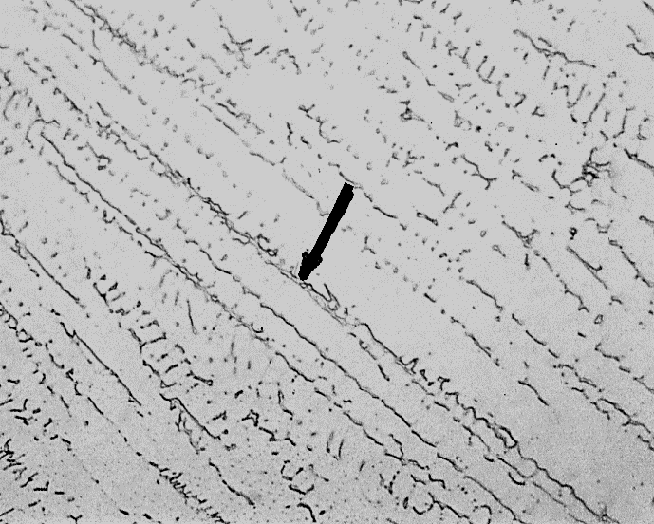
A small amount of ferrite prevents solidification cracking. Many owners’ welding specifications and API 582 states the minimum Ferrite Number in the weld is 3 (this is approximately 3% ferrite).
Figure 1 The arrow points to one of the many diagonal ferrite stringers in type 316L weld metal. The remainder is austenite. In some services, ferrite can preferentially corrode. 200X magnification
Many owners’ specifications won’t allow a Ferrite Number greater than 10 (about 10% ferrite). This is important if the operating temperature is above 550ºC. Above this temperature, the ferrite transforms to sigma. Sigma reduces impact toughness.
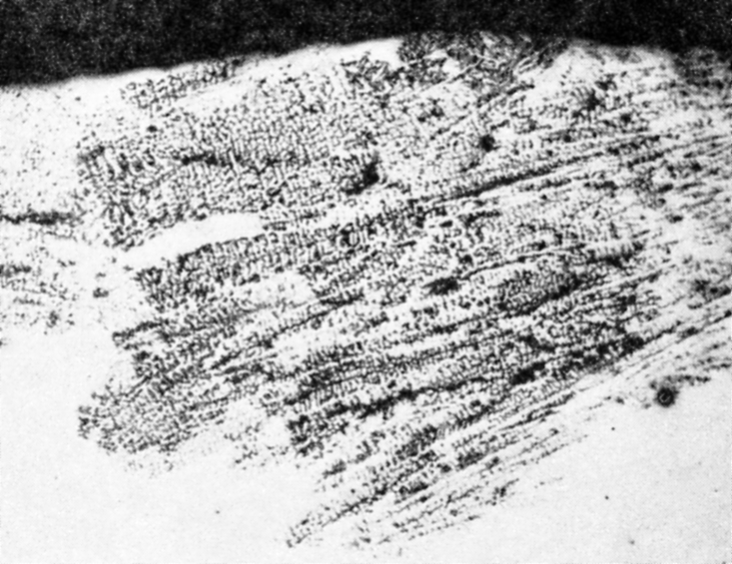
But sometimes owners insist the Ferrite Number cannot exceed 10 and yet the pipe operates at ambient temperature. Their concern is that weld ferrite can preferentially corrode. There is a description of this preferential corrosion in paragraph A8.21 of AWS A5.9
Owners believe a weld with a Ferrite Number greater than 10 will have a continuous network of ferrite, as shown in Figure 1. And corrosion will proceed quickly along the ferrite until the weld fails.
Figure 2 The black voids are areas of preferential ferrite corrosion. 7X magnification
As a result, the weld appears intact, but as noted in Figure 2, some areas are corroded. The weld ferrite is gone. Only a skelton of austenite remains.
Is this a problem in the oil and gas industry?
Chemical plants report preferential corrosion of ferrite in stainless steel welds but only in some services. It occurs in urea, sulfuric acid, hydrochloric acid, vinyl chloride, nitric acid, and acetic acid production. In most cases, only the weld ferrite corroded, the remainder of the pipe was intact.
This corrosion problem is reported mainly in type 316L weld metal. But this is because type 316L pipe is more common in chemical plants.
As noted above, only certain corrosive environments cause this preferential corrosion.
Microbiological induced corrosion (MIC) is a problem in the oil and gas industry. MIC occurs preferentially in the ferrite or preferentially in austenite or sometimes in both. Therefore, reducing the ferrite number may not prevent MIC.
Conclusions
- Chemical plants, especially those mentioned at the top of this page, can have preferential ferrite corrosion. This can lead to failure if the ferrite forms a continuous network through the weld.
Most of the literature recommends a maximum ferrite number of 5 for these industries. At this low ferrite number, there is insufficient ferrite to form a continuous network through the weld.
- Preferential ferrite corrosion in weld metal is not a problem in the oil and gas industry. But, if the operating temperature exceeds 550ºC, your welding specification must state the ferrite number cannot exceed 10. Above this temperature, excessive ferrite can embrittle the weld metal.
- MIC has occurred preferentially in either the austenite or ferrite or sometimes occurs in both. Therefore, reducing the ferrite number may not prevent MIC.
Have more questions? Contact us at bruce@LevanEngineering.com

AWS A5.9-2012, Specification for Bare Stainless Steel Welding Electrodes and Rods
Carruthers, M, Weld Corrosion in Type 316 and 316L Stainless Steels and Related Problems, June 1959, Welding Journal
Thomas, K., Comparison of MIC Pit Morphology with Non-MIC Chloride Induced Pits in Type 304/304L/E308 Stainless Steel Base Metals/Welds, paper 159, Corrosion 99

